Experiment 1: Flashing of LED Using AT89C51 Microcontroller Using Proteus

Aim
To write an assembly language program to flash the LED using the AT89C51 microcontroller.

Algorithm
- Start the program.
- Initialize the program memory from address 0000H.
- Set Port 2.0 high to turn ON the LED.
- Call the delay subroutine.
- Clear Port 2.0 to turn OFF the LED.
- Call the delay subroutine.
- Repeat the process continuously using an infinite loop.
- Stop.

Program
ORG 0000H
UP: SETB P2.0
ACALL DELAY
CLR P2.0
ACALL DELAY
SJMP UP
DELAY: MOV R4,#35
H1: MOV R3,#255
H2: DJNZ R3,H2
DJNZ R4,H1
RET
END

OUTPUT :

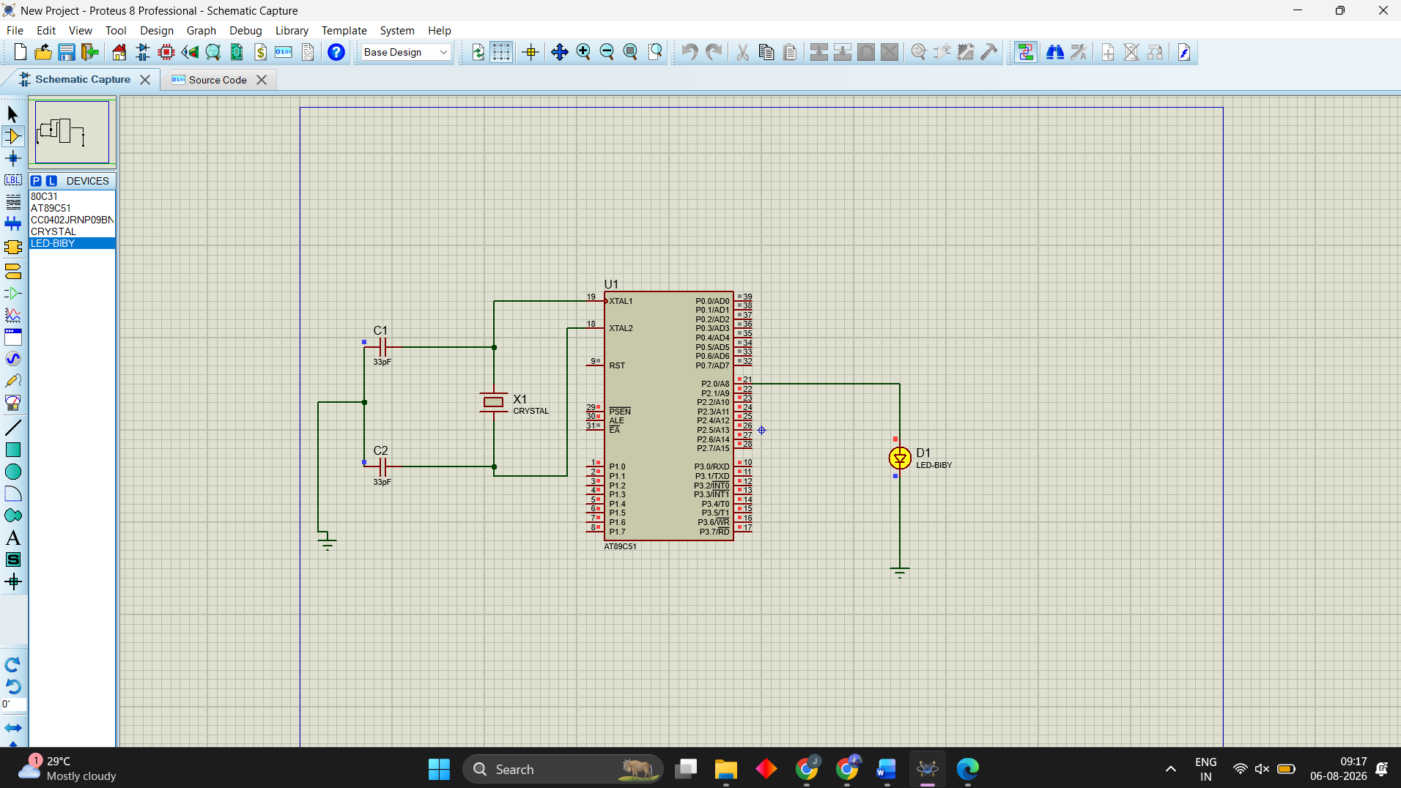

Result
Thus, the program has been successfully verified and executed.

